EEE-LAB

Name: O G Ragavi

Reg No: 20BCE1988

**LIGHT DIMMER CIRCUIT**

Aim:

To study the characteristics of transistor by designing a lamp dimmer circuit using darlington pair. Introduction:Transistors are an essential component in a sensor circuit. Usually transistors are

arranged as a pair, known as a ‘***DARLINGTON PAIR***’. It is very important that you can identify this

arrangement of transistors and state clearly why they are used. A darlington pair is used to amplify weak signals so that they can be clearly detected by another circuit.

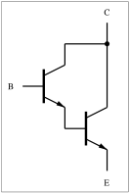

A Darlington pair behaves like a single transistor with a high current gain (approximately the product of the gains of the two transistors). In fact, integrated devices have three leads (B, C and E), broadly equivalent to those of a standard transistor.

A general relation between the compound current gain and the individual gains is given by:



If *β1* and *β2* are high enough (hundreds), this relation can be approximated with:



Circuit Diagram:

Case 1:

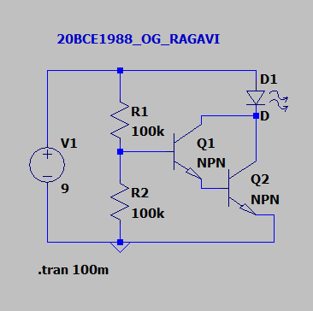

Simulation results:



Case 2:

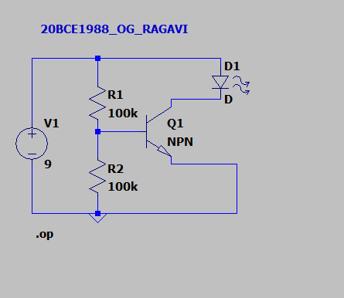

Simulation results:



**CASE1:**

|  |  |  |
| --- | --- | --- |
| R- Value(kΩ) | IB (A) | ID (A) |
| 100 | 8.26x10-5 | 0.023 |
| 150 | 8.25x10-5 | 0.023 |
| 200 | 8.25x10-5 | 0.023 |
| 250 | 8.25x10-5 | 0.023 |
| 300 | 8.25x10-5 | 0.023 |

**CASE2:**

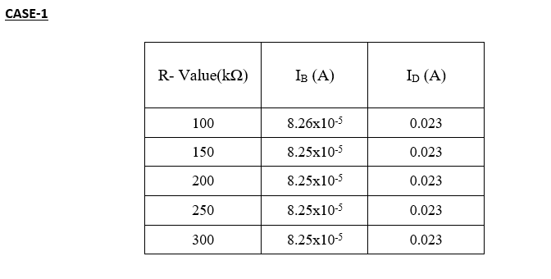

|  |  |  |
| --- | --- | --- |
| R- Value(kΩ) | IB (A) | ID (A) |
| 100 | 8.26x10-5 | 0.023 |
| 150 | 8.25x10-5 | 0.023 |
| 200 | 8.25x10-5 | 0.023 |
| 250 | 8.25x10-5 | 0.023 |
| 300 | 8.25x10-5 | 0.023 |



**Inference and Result:**

The characteristics of transistor are studied by designing a lamp dimmer circuit using darlington pair.